Extra 7-1 Add validation to the Reservation form

In this exercise, you’ll add validation to the Reservation form you created in exercise 6-1:

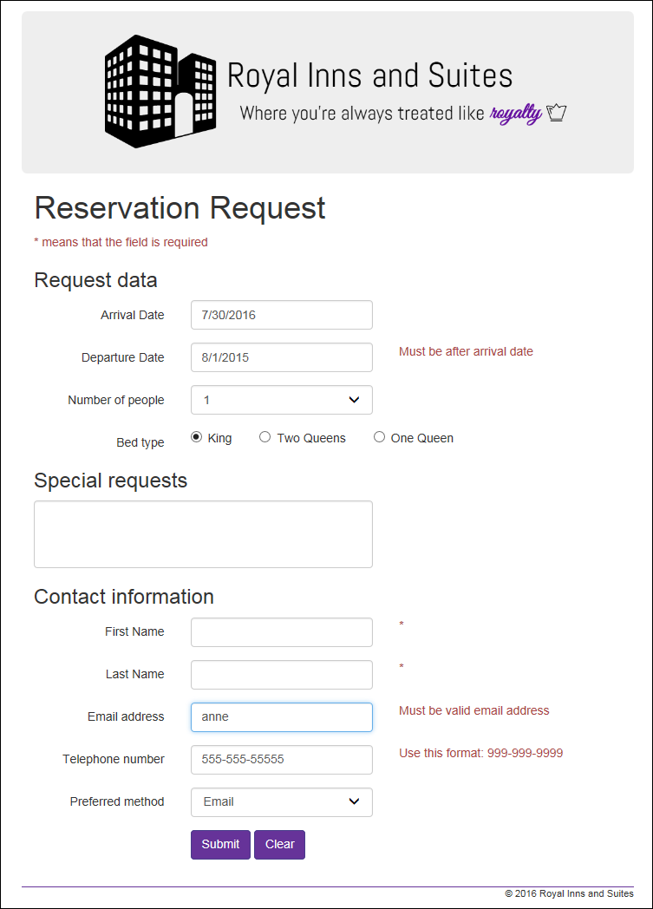

Add the required field validators

1. Open your finished project from Chapter 6.
2. Add a validation summary control between the h1 and h3 tags in the form element. This control should just display the message shown above. It shouldn’t display messages for individual validators. Set the CssClass property for this and all the other validators in this exercise to “text-danger”.
3. Add the required field validators to the right of the arrival date, departure date, first name, last name, email address, and telephone number fields. The error message should just be an asterisk.
4. Try to run the application, and note that the browser displays an error message because unobtrusive validation hasn’t been implemented. When you’re done reviewing this message, stop the application.

Implement unobtrusive validation and test the required field validators

1. Install the NuGet package for unobtrusive validation, as shown in figure 7-3. Note that you might need to select version 2.2.4 or earlier for the package to install without errors. Also, don’t forget to update the link tags in the head section of the document if the version numbers of the jQuery files change after the NuGet package installs.
2. Run the application again, and see that this time it loads without error.
3. Click the Submit button. The message for the validation summary control should be displayed at the top of the form, and asterisks should be displayed to the right of all the text boxes except for the first one. To test the validator for that text box, delete the default date that’s displayed and click the Submit button again.
4. Enter valid values for all of the text boxes, and click the Submit button again to see that the error messages are no longer displayed.
5. Click the Clear button to reset the form. Then, click the Clear button again to see that error messages are displayed. To fix that, you need to set the CausesValidation property of this button to False. Then, run the application again and test this button to be sure that validation errors aren’t displayed when it’s clicked.

Add the compare validators

1. Add a compare validator for the arrival date text box. This validator should check that a date is entered into this text box.
2. Add a compare validator for the departure date text box. This validator should check that the departure date is after the arrival date.
3. Test these validators, and fix any problems. When you test the arrival date for a valid date entry, keep in mind that many different formats are acceptable.

Add the regular expression validators

1. Add regular expression validators for the email address and telephone number fields.
2. Test these validators.

Make any final adjustments

1. Test the application one last time, and make any final adjustments. For instance, to get the error messages to display properly, the Display property for each one should be set to Dynamic, and the CssClass property should be set to “text-danger”.